Design Document for Spam Classifier:

Test Cases are run for

* lambda=0.1 and iterations=10000

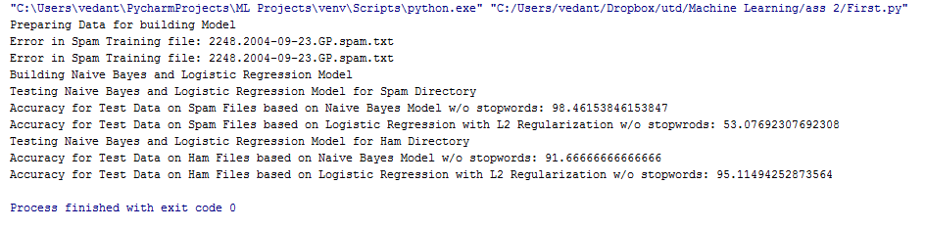

* lambda=0.01 and iterations=10000

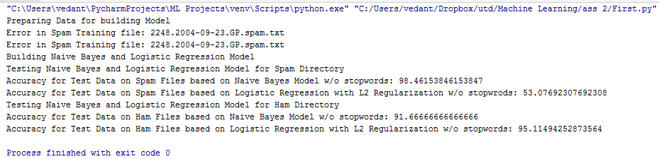

* lambda=0.1 and iterations=100000

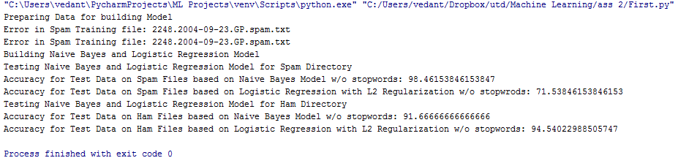

* lambda=0.01 and iterations=100000

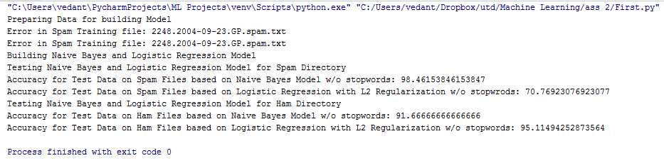

* lambda=0.1 and iterations=1000000

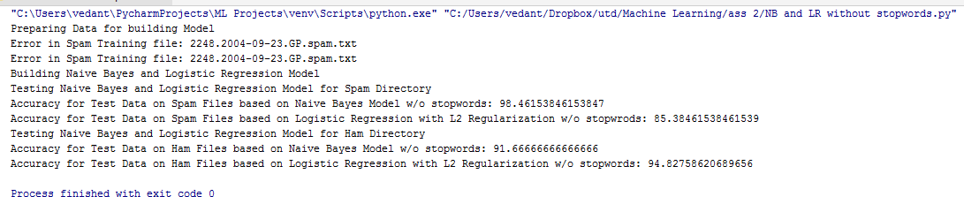

* lambda=0.01 and iterations=1000000



* lambda=0.01 and iterations=100000 with stop words in action

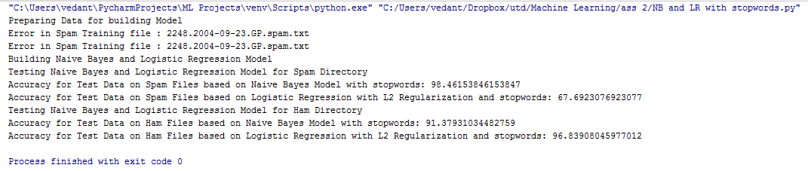

* lambda=0.01 and iterations=1000000 with stop words in action

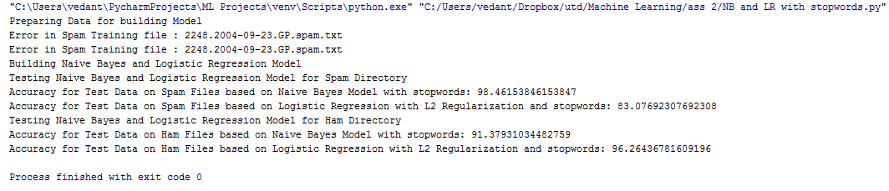

With the increase in the number of iterations the accuracy is getting better.

The accuracy reached is more than 90% using stopwords.